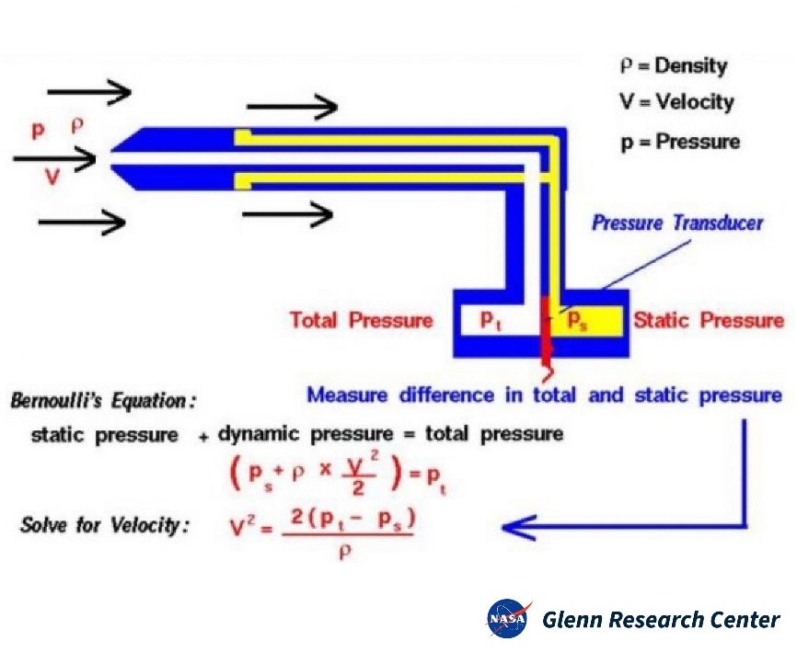

Image Source: <https://www.researchgate.net/figure/Schematic-diagram-of-a-Prandtl-tube_fig2_226082529>

The above equation is derived from Bernoulli’s equation.

Let:

$$v=100mph=44.704\frac{m}{s}=Maximum estimated velocity \\ ρ_{air}=1.204\frac{kg}{m^{3}}=Air Density \\ P_{s}=101.325 kPa=Atmospheric Pressure$$

Solve for $P_{t}$:

$$v^{2}=\frac{2\left(P_{t}-P_{s}\right)}{ρ_{air}}→\frac{v^{2}ρ_{air}}{2}+P_{s} \\ →P_{t}=\frac{1}{2}v^{2}ρ_{air}+P_{s} \\ →P_{t}=\frac{1}{2}{\left(44.704\frac{m}{s}\right)}^{2}\left(1.204\frac{kg}{m^{3}}\right)+101325\frac{N}{m^{2}} \\ →P_{t}=\frac{1}{2}\left(1998.45\frac{m^{2}}{s^{2}}\right)\left(1.204\frac{kg}{m^{3}}\right)+101325\frac{N}{m^{2}} \\ →P_{t}=\frac{1}{2}\left(2406.13\frac{kg}{m*s^{2}}\right)+101325\frac{kg*m}{m^{2}*s^{2}} \\ →P_{t}=1203.07 Pa+101325 Pa \\ →P_{t}=102.528 kPa$$

Define:

$$ΔP=P_{t}-P_{s}=\left(102.528-101.325\right)kPa=1.203kPa$$

From the datasheet for mpx5010dp:

Pressure range: 10kPa

This value is larger than the anticipated 1.203kPa difference expected in testing conditions.

The maximum airspeed velocity may be thus calculated:

$$v^{2}=\frac{2ΔP}{ρ_{air}} \\ →v=\sqrt{\frac{2ΔP}{ρ_{air}}}=\sqrt{\frac{2(10,000 Pa)}{1.204\frac{kg}{m^{3}}}}=128\frac{m}{s}=286.328 mph MAXIMUM$$

This value is considerably higher than will be achieved during flight testing. The mpx5010dp is an appropriate sensor for this application.

Transfer function:

$$V_{out}=V_{s}\left(0.09*P+0.04\right)±0.05*V_{FSS} \\ →\frac{V_{out}±0.05V_{FSS}}{V_{s}}=0.09*P+0.04 \\ →P=\frac{1}{0.09}\left(\frac{V_{out}±0.05V_{FSS}}{V_{s}}-0.04\right)$$

Where:

$$P=Pressure Read \left(kPa\right) \\ V_{out}=Voltage from sensor data pin \\ V_{S}=5V=Supply Voltage \\ V_{FSS}=\left(4.5±0.225\right)V=Full Scale Span$$

Note: $V_{out}, V_{s}, V_{FSS}$ can be in any voltage units (V, mV, uV, etc), but they must be consistent!

This pressure is equivalent to the pressure difference:

$$P=ΔP_{sensor}=P_{t}-P_{s}$$

With pressure difference determined, we may calculate wind speed with the modified Bernoulli equation from above:

$$v=\sqrt{\frac{2\left(P_{t}-P_{s}\right)}{ρ_{air}}}=\sqrt{\frac{2ΔP_{sensor}}{ρ_{air}}}$$

Our pressure units are in kPa and must be converted to Pa obtain m/s units:

$$v=\sqrt{\frac{2ΔP_{sensor}*1000}{ρ_{air}}}=Velocity \left(\frac{m}{s}\right) \\ →v=\sqrt{\frac{2}{ρ_{air}}\left(ΔP_{sensor}*1000\right)}=\sqrt{\frac{2}{ρ_{air}}\left(\frac{1}{0.09}\left(\frac{V_{out}±0.05V_{FSS}}{V_{s}}-0.04\right)*1000\right)}=Velocity \left(\frac{m}{s}\right)$$

Next we must convert m/s velocity to mph:

$$v_{mph}=\sqrt{\frac{2}{ρ_{air}}\left(\frac{1}{0.09}\left(\frac{V_{out}±0.05V_{FSS}}{V_{s}}-0.04\right)*1000\right)}*conversion \\ conversion=2.23694$$

$V_{out}$ cannot be read directly by the Arduino. We must convert the 0-1023 back to volage:

$$V_{out}\left(mV\right)=SensorReading_{\left(bits\right)}*\frac{5000mV}{1023bits}=4.8828125*SensorReading_{\left(bits\right)}$$

Written numerically, excluding the $±$ error term:

$$v_{mph}=2.23694\sqrt{\frac{2}{1.204}\left(\frac{1}{0.09}\left(\frac{4.8828125\frac{mV}{bit}*SensorReading_{\left(bits\right)}}{5000 mV}-0.04\right)*1000\right)} \\ →v_{mph}=2.23694\sqrt{18456.9952\left(\frac{4.8828125\frac{mV}{bit}*SensorReading_{\left(bits\right)}}{5000 mV}-0.04\right)} \\ →v_{mph}=2.23694\sqrt{18.024409*SensorReading_{\left(bits\right)}-738.279808}$$

Use this to obtain velocity